LAB EXAM

Submitted by

Anusree T K

208

1.install linux on virtual box in windows 10

2.use sed command to replace the content of the file(emulate tac command)

3.I want to create a directory such that any one in the group can create and file and access any persons file in it but none should be able to delete a file other than the one created himself

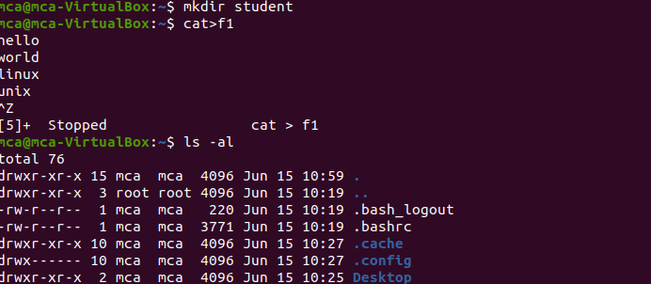

4. write a script to print 10 elements of fibccoci series

5.Wireshark

